## **Pioneering present-day pedagogy**

**Integrating modern trends, technology, and innovation into their curricula, Indian management institutes are focusing on nurturing future generation to embrace the challenges of change.**

Digital transformations have not only academic landscape but also revolutionized workplace trends prompting the emergence of new age courses poised to embrace this change. while management education remains highly sought after, program demonstrating greater adaptability to modern trends are now under the spotlight. management degrees in India attract many students.

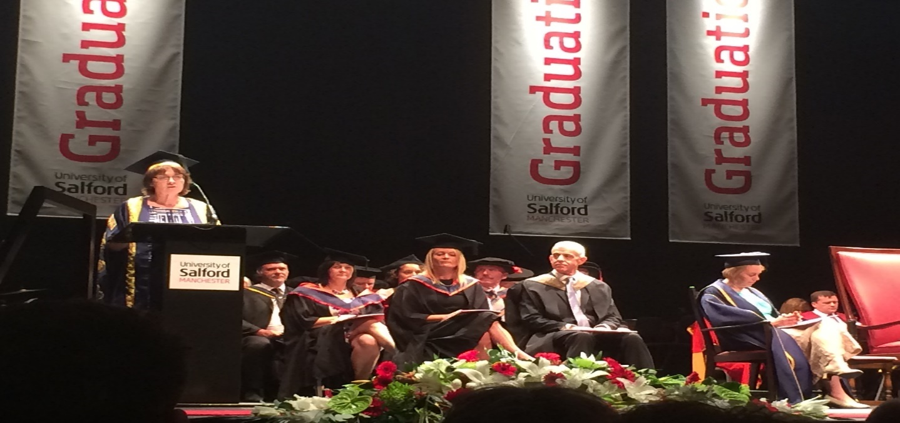

, driven by the promise of lucrative salaries and leadership opportunities spanning various industries.

The country thriving economy further fuels this demand, resulting in a robust job market for management graduates beyond imparting technical knowledge, these programs focus on nurturing communication, problem solving and critical thinking skill essentials for long term career success.